Our Target Audience

### The majority of the audience

From the research I have made from the top grossing multiplayer games, I have found that the target audience for our game are females in the age range of 21-35. In locations, that are in-between the middle class – higher class. They also seem to not pay like male players do.

Multiplayer games such as Candy Crush Saga and Bejeweled Blitz are casual games with similar art styles and have the same kind of challenge. I have chosen these two games as my main source as it gives me enough information to compare these two games to find our majority demographic and to find which attracts the highest audience. (Mike Mason, 2013)

##### Features of both games:

* They like jewels which are shiny and shiny food. More feminine.
* Characters in candy crush are “cutesy”
* The colours are primary and secondary colours and are bright and vibrant. It also has pearly whites (bejewled)
* Bejewled – it has a colourful phoenix – has very feminine colours – fiery pale lighting trail – its stands out. Purple and yellow – complimentary colours
* Phoenix – colours – gradients from red to blue with pinkish purple-ish undertones.
* Candy Crush Saga – there is a setting of a candy world – so has fantasy like the phoenix in bejewled
* Characters are paper – showing creativeness and artistic – crafts

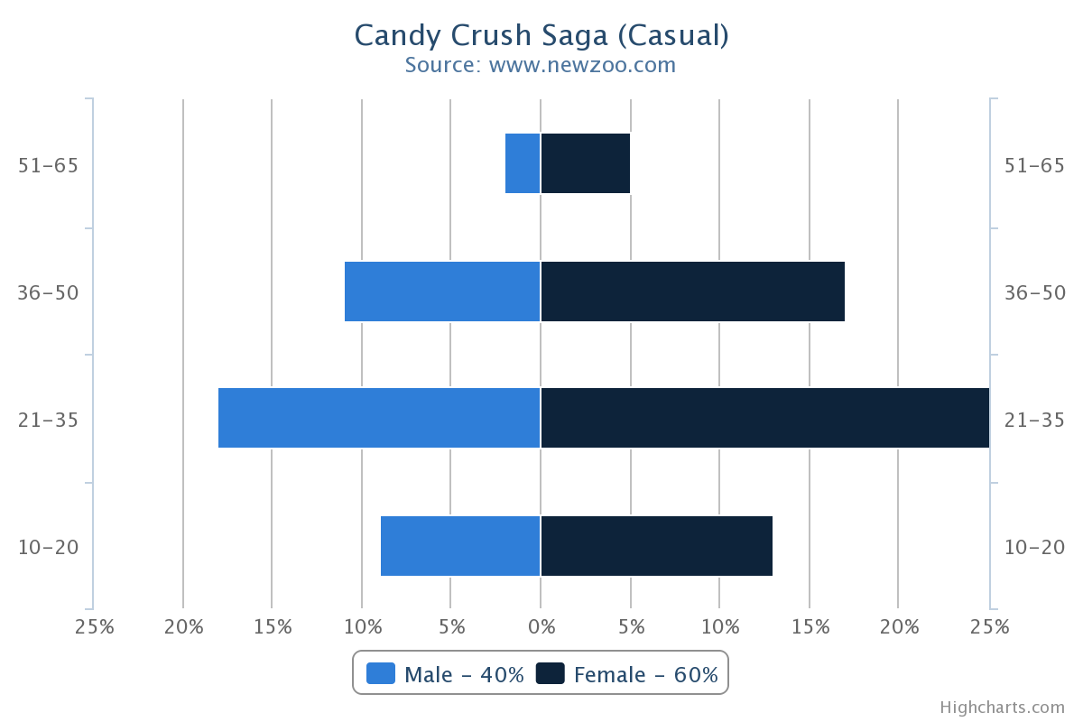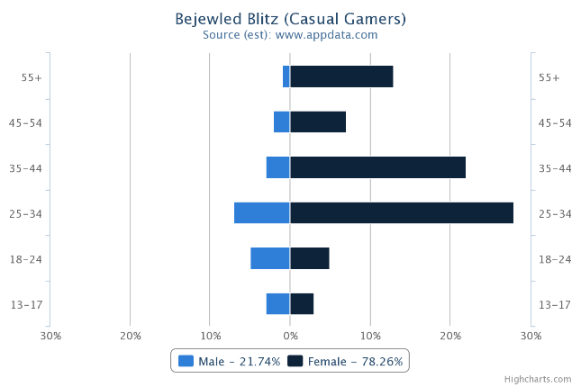From these stats it shows that Candy Crush has a dominating attraction from a larger audience.

Fig 1 and fig 2 Stats for Casual Games (Mike Mason, 2013)

Now I will relate the demographics research to pinpoint what our audience want in the game

Comparison to find which game is more effective – Extra

I decided to download the games onto my phone and play them, I then listed the similar and different features both games have:

### Similarities and Differences

##### Similarities

* They both are the same matching puzzle game
* They both use male voices
* Different game modes – different difficulties
* Both have themed settings for the game
* Both games ask for your name

##### Differences

* Bejewled isn’t as rewarding, tutorial is allowing the user to find out for themselves, more experienced casual gamers, straight into the game
* Candy Crush - Tutorial, has a character show what gestures to use and has a lot of rewards already. First few episodes are tutorials, introducing new objectives.
* Candy crush has a level select whereas bejeweled takes you straight to the next level
* Candy Crush - After each level, results come in on how well the player did, providing information like the target, how many stars they got (performance) and the score you got.
* Candy Crush helps by lighting up and showing the person hints, bejweled is tougher.
* Candy Crush constantly shows points and scores and gives feedback to the player on each move.
* Candy crush music is very cheery and goes with the fantasy theme but creates a hyped atmosphere
* Bejewled music is more melodic and ambient. It’s got as very mystical vibe but more on the relaxed mood. More one player than multiplayer.
* Bejewled gives you a large option of different play modes. – the difficulty is more advanced
* Candy Crush also gives different play modes but has an easy difficulty mode
* Candy crush has a flowing theme of candy world throughout the levels
* Bejewled has different settings depending which game mode is chosen but still has a continuation of the theme mystical fantasy throughout the different sets.
* Candy crush gives the players boosters and gives the player a mastery counter which counts up all the stars and score that have been obtained and then adds it onto a meter.
* Candy Crush has different map layouts
* Candy Crush has a timer
* Candy Crush motivates you to play more, to progress to the next level
* Candy Crush is very rewarding

### How we can apply this information to our game.

As Candy Crush has more features that attracts more people, I will take out features of this game that really grasp the audience and apply some of those features in a similar way in our game.

# Features to apply to our game:

* Visual feedback: Scores, Points, good moves; the way it feedbacks to the users made it more motivating to complete challenges and go through the map as it gives it a flow
* Sound feedbacks: Sounds and Music – upbeat music, sounds for each movement the user makes, sounds to say if they are wrong or right.
* Reward - points – after each round give players a stat of their score and performance
* Tutorial
* Timer
* Highlighting or lighting up objects to show user what to do.

# References

Mike Mason (19 December, 2013) *Demographic Breakdown of Casual, Mid-Core and Hard-Core Mobile Gamers.* Available at:<http://developers.magmic.com/demographic-breakdown-casual-mid-core-hard-core-mobile-gamers/> (Accessed: 1st/02/2018)